Coronavirus disease 2019 (COVID-19)
Situation Report – 73

Data as reported by national authorities by 10:00 CET 2 April 2020

HIGHLIGHTS
- No new countries/territories/areas reported cases of COVID-19 in the past 24 hours.

- WHO has released a Medical Product Alert that warns consumers, healthcare professionals, and health authorities against a growing number of falsified medical products that claim to prevent, detect, treat or cure COVID-19. Find more here.

- WHO is working with Iraq to increase surveillance and response capacities. WHO has printed hundreds of thousands of prevention and transmission control messages, taken mobile health teams to the streets, and delivered urgent consignments of personal protective equipment (PPE) and laboratory test kits. More information can be found here.

- WHO has been working with governments and partners around the world, across many areas of activity: conducting needs assessments, providing hand sanitizers and masks for health professionals, providing training on the clinical management of patients with COVID-19, collaborating with local media outlets and conducting awareness raising activities, delivering test kits, conducting simulation exercises, and shipping personal protective equipment through WHO logistical hubs. As an example, WHO EURO has released a photo story of WHO’s activities in Kyrgyzstan, available here.

- Our understanding of the transmission of COVID-19 virus continues to improve with the evolution of the outbreak. For more, see ‘Subject in Focus’.
SITUATION IN NUMBERS
total (new) cases in last 24 hours

Globally
896 450 confirmed (72 839)
45 525 deaths (4923)

Western Pacific Region
107 626 confirmed (1204)
3723 deaths (22)

European Region
503 006 confirmed (38 809)
33 604 deaths (3515)

South-East Asia Region
5324 confirmed (149)
216 deaths (21)

Eastern Mediterranean Region
58 168 confirmed (3887)
3279 deaths (164)

Region of the Americas
216 912 confirmed (28161)
4565 deaths (1165)

African Region
4702 confirmed (629)
127 deaths (36)

WHO RISK ASSESSMENT
Global Level Very High

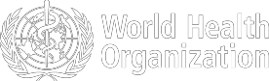
Figure 1. Countries, territories or areas with reported confirmed cases of COVID-19, 2 April 2020

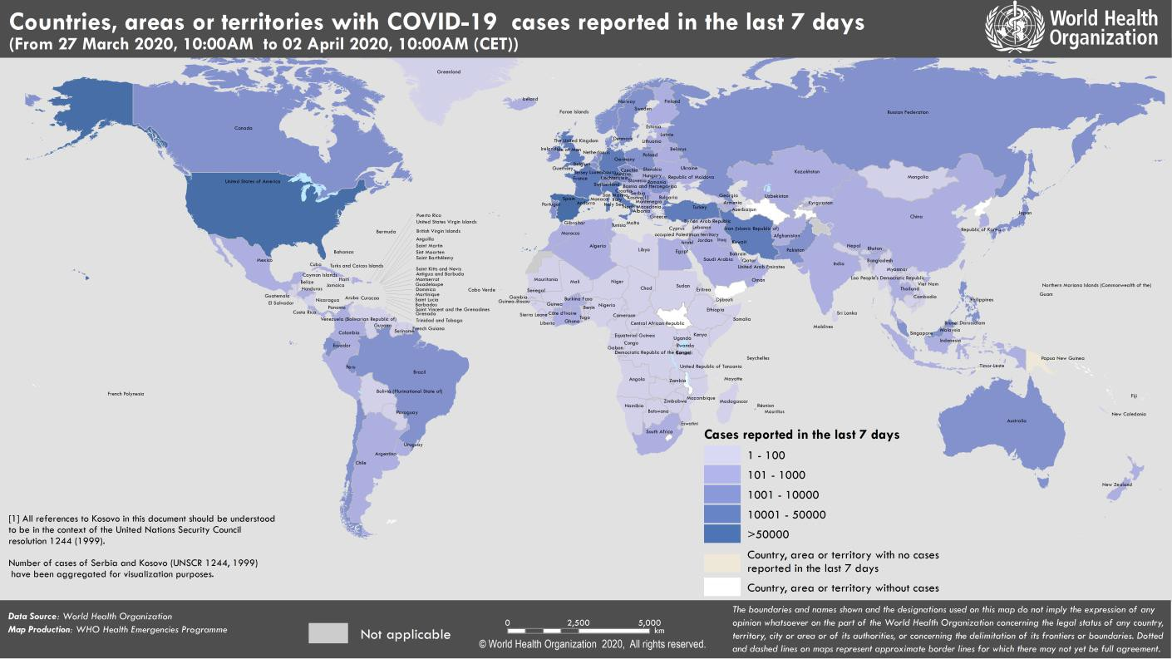

SUBJECT IN FOCUS: The routes of transmission from COVID-19 patients

As the COVID-19 outbreak continues to evolve, we are learning more about this new virus every day. Here we summarize what has been reported about transmission of the COVID-19 virus, and provide a brief overview of available evidence on transmission from symptomatic, pre-symptomatic and asymptomatic people infected with COVID-19.

Symptomatic transmission
By way of definition, a symptomatic COVID-19 case is a case who has developed signs and symptoms compatible with COVID-19 virus infection. Symptomatic transmission refers to transmission from a person while they are experiencing symptoms.

Data from published epidemiology and virologic studies provide evidence that COVID-19 is primarily transmitted from symptomatic people to others who are in close contact through respiratory droplets, by direct contact with infected persons, or by contact with contaminated objects and surfaces.1-7 This is supported by detailed experiences shared by technical partners via WHO global expert networks, and reports and presentations by Ministries of Health.

Data from clinical and virologic studies that have collected repeated biological samples from confirmed patients provide evidence that shedding of the COVID-19 virus is highest in upper respiratory tract (nose and throat) early in the course of the disease.8-11 That is, within the first 3 days from onset of symptoms.10-11 Preliminary data suggests that people may be more contagious around the time of symptom onset as compared to later on in the disease.

Pre-symptomatic transmission
The incubation period for COVID-19, which is the time between exposure to the virus (becoming infected) and symptom onset, is on average 5-6 days, however can be up to 14 days. During this period, also known as the “pre- symptomatic” period, some infected persons can be contagious. Therefore, transmission from a pre-symptomatic case can occur before symptom onset.

In a small number of case reports and studies, pre-symptomatic transmission has been documented through contact tracing efforts and enhanced investigation of clusters of confirmed cases.12-17 This is supported by data suggesting that some people can test positive for COVID-19 from 1-3 days before they develop symptoms.6,16 Thus, it is possible that people infected with COVID-19 could transmit the virus before significant symptoms develop. It is important to recognize that pre-symptomatic transmission still requires the virus to be spread via infectious droplets or through touching contaminated surfaces.

Asymptomatic transmission
An asymptomatic laboratory-confirmed case is a person infected with COVID-19 who does not develop symptoms. Asymptomatic transmission refers to transmission of the virus from a person, who does not develop symptoms.

There are few reports of laboratory-confirmed cases who are truly asymptomatic, and to date, there has been no documented asymptomatic transmission. This does not exclude the possibility that it may occur. Asymptomatic cases have been reported as part of contact tracing efforts in some countries.

WHO regularly monitors all emerging evidence about this critical topic and will provide an update as more information becomes available.

Selected references
- Liu J, Liao X, Qian S et al. Community transmission of severe acute respiratory syndrome coronavirus 2, Shenzhen, China, 2020. Emerg Infect Dis 2020 doi.org/10.3201/eid2606.200239
- Chan J, Yuan S, Kok K et al. A familial cluster of pneumonia associated with the 2019 novel coronavirus indicating person-to-person transmission: a study of a family cluster. Lancet 2020 doi: 10.1016/S0140- 6736(20)30154-9
- Li Q, Guan X, Wu P, et al. Early transmission dynamics in Wuhan, China, of novel coronavirus-infected pneumonia. N Engl J Med 2020; doi:10.1056/NEJMoa2001316.
- Huang C, Wang Y, Li X, et al. Clinical features of patients infected with 2019 novel coronavirus in Wuhan, China. Lancet 2020; 395: 497–506.
- Burke RM, Midgley CM, Dratch A, Fenstersheib M, Haupt T, Holshue M,et al. Active monitoring of persons exposed to patients with confirmed COVID-19 — United States, January–February 2020. MMWR Morb Mortal Wkly Rep. 2020 doi : 10.15585/mmwr.mm6909e1external icon
- World Health Organization. Report of the WHO-China Joint Mission on Coronavirus Disease 2019 (COVID-19) 16-24 February 2020 [Internet]. Geneva: World Health Organization; 2020 Available from: https://www.who.int/docs/default- source/coronaviruse/who-china-joint-mission-on-covid-19-final- report.pdf
- Ong SW, Tan YK, Chia PY, Lee TH, Ng OT, Wong MS, et al. Air, surface environmental, and personal protective equipment contamination by severe acute respiratory syndrome coronavirus 2 (SARS-CoV-2) from a symptomatic patient. JAMA. 2020 Mar 4 [Epub ahead of print].
- Wang W, Xu Y, Ruqin G, et al. Detection of SARS-CoV-2 in Different Types of Clinical Specimens. JAMA 2020 doi:10.1001/jama.2020.3786.
- Lauer SA, Grantz KH, Bi Q et al. The Incubation Period of Coronavirus Disease 2019 (COVID-19) From Publicly Reported Confirmed Cases: Estimation and Application. Ann Intern Med 2020 doi: 10.7326/M20-0504.
- Liu Y, Yan LM, Wan L et al. Viral dynamics in mild and severe cases of CVOID-19. Lancet Infect Dis doi.org/10.1016/S1473-3099(20)30232-2
- Wolfel R, Corman V, Guggemos W et al Virological assessment of hospitalized cases of coronavirus disease 2019. doi: 10.1101/2020.03.05.20030502.
- Yu P, Zhu J, Zhang Z, Han Y. A familial cluster of infection associated with the 2019 novel coronavirus indicating possible person-to-person transmission during the incubation period. J Infect 2020 doi: 10.1093/jiaa077
- Huang R, Xia J, Chen Y, Shan C, Wu C. A family cluster of SARS-CoV-2 infection involving 11 patients in Nanjing, China Lancet Infect Dis 2020 doi: 10.1016/ S1473-3099(20)30147-X
- Pan X, Chen D, Xia Y et al. Asymptomatic cases in a family cluster with SARS-CoV-2 infection. Lancet Infect Dis 2020 doi : 10.1016/ S1473-3099(20)30114-6
- Tong Z-D, Tang A, Li K-F, Li P, Wang H-L, Yi J-P, et al. Potential presymptomatic transmission of SARS-CoV-2, Zhejiang Province, China, 2020. Emerg Infect Dis. 2020 doi : 10.3201/eid2605.200198
- Wei WE, Li Z, Chiew CJ, Yong SE, et al. Presymptomatic Transmission of SARS-CoV-2 — Singapore, January 23–March 16, 2020. MMWR, 1 April 2020/69.
- Kimball A, Hatfield KM, Arons M, James A, et al. Asymptomatic and Presymptomatic SARS-CoV-2 Infections in Residents of a Long-Term Care Skilled Nursing Facility — King County, Washington, March 2020. MMWR, 3 April 2020, 69(13);377–381.
SURVEILLANCE

Table 1. Countries, territories or areas with reported laboratory-confirmed COVID-19 cases and deaths. Data as of 2 April 2020*
Reporting Country/ Territory/Area† | Total confirmed  ‡ cases |  | Total confirmed new cases | Total deaths | Total new deaths | Transmission classification§ | Days since last reported case
Western Pacific Region
China |  | 82724 | 93 | 3327 | 6 | Local transmission | 0
Republic of Korea |  | 9976 | 89 | 169 | 4 | Local transmission | 0
Australia |  | 4976 | 269 | 21 | 1 | Local transmission | 0
Malaysia |  | 2908 | 142 | 45 | 2 | Local transmission | 0
Japan |  | 2384 | 206 | 57 | 0 | Local transmission | 0
Philippines |  | 2311 | 227 | 96 | 8 | Local transmission | 0
Singapore |  | 1000 | 74 | 3 | 0 | Local transmission | 0
New Zealand |  | 723 | 76 | 1 | 0 | Local transmission | 0
Viet Nam |  | 218 | 11 | 0 | 0 | Local transmission | 0
Brunei Darussalam |  | 131 | 2 | 1 | 0 | Local transmission | 0
Cambodia |  | 109 | 0 | 0 | 0 | Local transmission | 1
Mongolia |  | 14 | 2 | 0 | 0 | Imported cases only | 0
Lao People's Democratic Republic |  | 10 | 1 | 0 | 0 | Local transmission | 0
Fiji |  | 5 | 0 | 0 | 0 | Local transmission | 7
Papua New Guinea |  | 1 | 0 | 0 | 0 | Imported cases only | 12
Territories**
Guam |  | 77 | 8 | 3 | 1 | Local transmission | 0
French Polynesia |  | 37 | 0 | 0 | 0 | Local transmission | 1
New Caledonia |  | 16 | 0 | 0 | 0 | Local transmission | 1
Northern Mariana Islands (Commonwealth of the) |  | 6 | 4 | 0 | 0 | Local transmission | 0
European Region
Italy |  | 110574 | 4782 | 13157 | 727 | Local transmission | 0
Spain |  | 102136 | 7719 | 9053 | 864 | Local transmission | 0
Germany |  | 73522 | 6156 | 872 | 140 | Local transmission | 0
France |  | 56261 | 4784 | 4019 | 505 | Local transmission | 0
The United Kingdom |  | 29478 | 4324 | 2532 | 743 | Local transmission | 0
Switzerland |  | 17070 | 962 | 378 | 5 | Local transmission | 0
Turkey |  | 15679 | 2148 | 277 | 63 | Local transmission | 0
Belgium |  | 13964 | 1189 | 828 | 123 | Local transmission | 0
Netherlands |  | 13614 | 1019 | 1173 | 134 | Local transmission | 0
Austria |  | 10711 | 529 | 146 | 18 | Local transmission | 0
Portugal |  | 8251 | 808 | 187 | 27 | Local transmission | 0
Israel |  | 5591 | 462 | 21 | 0 | Local transmission | 0
Sweden |  | 4947 | 512 | 239 | 59 | Local transmission | 0
Norway |  | 4665 | 218 | 32 | 4 | Local transmission | 0
Czechia |  | 3589 | 281 | 39 | 8 | Local transmission | 0
Ireland |  | 3447 | 212 | 85 | 14 | Local transmission | 0

Denmark | 3107 | 247 | 104 | 14 | Local transmission | 0
Russian Federation | 2777 | 440 | 24 | 7 | Local transmission | 0
Poland | 2554 | 243 | 43 | 10 | Local transmission | 0
Romania | 2460 | 215 | 85 | 16 | Local transmission | 0
Luxembourg | 2319 | 141 | 29 | 6 | Local transmission | 0
Finland | 1446 | 62 | 17 | 0 | Local transmission | 0
Greece | 1375 | 61 | 50 | 1 | Local transmission | 0
Iceland | 1220 | 85 | 2 | 0 | Local transmission | 0
Serbia | 1060 | 160 | 13 | 0 | Local transmission | 0
Croatia | 963 | 96 | 6 | 0 | Local transmission | 0
Slovenia | 841 | 27 | 15 | 2 | Local transmission | 0
Ukraine | 804 | 135 | 20 | 3 | Local transmission | 0
Estonia | 779 | 34 | 5 | 1 | Local transmission | 0
Lithuania | 581 | 48 | 8 | 1 | Local transmission | 0
Armenia | 571 | 39 | 3 | 0 | Local transmission | 0
Hungary | 525 | 33 | 20 | 4 | Local transmission | 0
Bosnia and Herzegovina | 464 | 51 | 13 | 1 | Local transmission | 0
Latvia | 446 | 48 | 0 | 0 | Local transmission | 0
Republic of Moldova | 423 | 70 | 5 | 2 | Local transmission | 0
Bulgaria | 422 | 23 | 10 | 2 | Local transmission | 0
Slovakia | 400 | 37 | 0 | 0 | Local transmission | 0
Andorra | 396 | 20 | 13 | 1 | Local transmission | 0
Kazakhstan | 386 | 38 | 3 | 1 | Local transmission | 0
Azerbaijan | 359 | 61 | 5 | 0 | Local transmission | 0
North Macedonia | 354 | 25 | 11 | 2 | Local transmission | 0
Cyprus | 320 | 58 | 9 | 1 | Local transmission | 0
Albania | 277 | 34 | 15 | 2 | Local transmission | 0
San Marino | 236 | 0 | 28 | 2 | Local transmission | 1
Belarus | 192 | 40 | 2 | 2 | Local transmission | 0
Uzbekistan | 190 | 17 | 2 | 0 | Local transmission | 0
Malta | 188 | 21 | 0 | 0 | Local transmission | 0
Georgia | 121 | 6 | 0 | 0 | Local transmission | 0
Montenegro | 120 | 15 | 2 | 0 | Local transmission | 0
Kyrgyzstan | 115 | 4 | 0 | 0 | Local transmission | 0
Liechtenstein | 72 | 4 | 0 | 0 | Under investigation | 0
Monaco | 37 | 0 | 0 | 0 | Local transmission | 1
Holy See | 6 | 0 | 0 | 0 | Under investigation | 3
Territories**
Faroe Islands | 173 | 4 | 0 | 0 | Local transmission | 0
Kosovo[1] | 125 | 13 | 1 | 0 | Local transmission | 0
Gibraltar | 69 | 0 | 0 | 0 | Local transmission | 2
Jersey | 81 | 18 | 2 | 0 | Local transmission | 0
Guernsey | 78 | 18 | 1 | 0 | Local transmission | 0
Isle of Man | 65 | 13 | 0 | 0 | Local transmission | 0
Greenland | 10 | 0 | 0 | 0 | Under investigation | 4
South-East Asia Region
Thailand | 1771 | 0 | 12 | 0 | Local transmission | 1
Indonesia | 1677 | 149 | 157 | 21 | Local transmission | 0
India | 1636 | 0 | 38 | 0 | Local transmission | 1

Sri Lanka | 143 | 0 | 2 | 0 | Local transmission | 1
Bangladesh | 54 | 0 | 6 | 0 | Local transmission | 1
Maldives | 18 | 0 | 0 | 0 | Local transmission | 1
Myanmar | 15 | 0 | 1 | 0 | Local transmission | 1
Nepal | 5 | 0 | 0 | 0 | Imported cases only | 4
Bhutan | 4 | 0 | 0 | 0 | Imported cases only | 3
Timor-Leste | 1 | 0 | 0 | 0 | Under investigation | 12
Eastern Mediterranean Region
Iran (Islamic Republic of) | 47593 | 2987 | 3036 | 138 | Local transmission | 0
Pakistan | 2291 | 252 | 31 | 5 | Local transmission | 0
Saudi Arabia | 1720 | 157 | 16 | 6 | Local transmission | 0
Qatar | 835 | 54 | 2 | 0 | Local transmission | 0
United Arab Emirates | 814 | 150 | 8 | 2 | Local transmission | 0
Egypt | 779 | 69 | 52 | 6 | Local transmission | 0
Iraq | 728 | 34 | 52 | 2 | Local transmission | 0
Morocco | 676 | 38 | 39 | 3 | Local transmission | 0
Bahrain | 569 | 2 | 4 | 0 | Local transmission | 0
Lebanon | 479 | 16 | 12 | 0 | Local transmission | 0
Tunisia | 423 | 29 | 12 | 2 | Local transmission | 0
Kuwait | 317 | 28 | 0 | 0 | Local transmission | 0
Jordan | 278 | 4 | 5 | 0 | Local transmission | 0
Afghanistan | 235 | 43 | 4 | 0 | Local transmission | 0
Oman | 231 | 21 | 1 | 0 | Local transmission | 0
Djibouti | 34 | 3 | 0 | 0 | Local transmission | 0
Libya | 10 | 0 | 0 | 0 | Local transmission | 1
Syrian Arab Republic | 10 | 0 | 2 | 0 | Imported cases only | 2
Sudan | 7 | 0 | 2 | 0 | Imported cases only | 1
Somalia | 5 | 0 | 0 | 0 | Imported cases only | 1
Territories**
occupied Palestinian territory | 134 | 0 | 1 | 0 | Local transmission | 1
Region of the Americas
United States of America | 187302 | 24103 | 3846 | 996 | Local transmission | 0
Canada | 9005 | 1310 | 105 | 16 | Local transmission | 0
Brazil | 5717 | 1138 | 201 | 42 | Local transmission | 0
Chile | 3031 | 293 | 16 | 4 | Local transmission | 0
Ecuador | 2372 | 132 | 146 | 71 | Local transmission | 0
Peru | 1323 | 258 | 24 | 0 | Local transmission | 0
Dominican Republic | 1284 | 175 | 57 | 6 | Local transmission | 0
Mexico | 1215 | 121 | 29 | 1 | Local transmission | 0
Panama | 1181 | 192 | 30 | 6 | Local transmission | 0
Argentina | 1054 | 88 | 27 | 3 | Local transmission | 0
Colombia | 906 | 108 | 16 | 2 | Local transmission | 0
Costa Rica | 347 | 33 | 2 | 0 | Local transmission | 0
Uruguay | 338 | 18 | 2 | 1 | Local transmission | 0
Cuba | 212 | 26 | 6 | 0 | Local transmission | 0
Honduras | 172 | 33 | 10 | 8 | Local transmission | 0

Venezuela (Bolivarian Republic of) | 143 | 14 | 3 | 0 | Local transmission | 0
Bolivia (Plurinational State of) | 115 | 8 | 7 | 1 | Local transmission | 0
Trinidad and Tobago | 89 | 4 | 5 | 2 | Local transmission | 0
Paraguay | 69 | 4 | 3 | 0 | Local transmission | 0
Guatemala | 39 | 3 | 1 | 0 | Local transmission | 0
Jamaica | 38 | 2 | 1 | 0 | Local transmission | 0
Barbados | 33 | 0 | 0 | 0 | Local transmission | 2
El Salvador | 32 | 2 | 1 | 1 | Local transmission | 0
Guyana | 19 | 7 | 2 | 0 | Local transmission | 0
Haiti | 16 | 1 | 0 | 0 | Imported cases only | 0
Bahamas | 15 | 1 | 0 | 0 | Local transmission | 0
Saint Lucia | 13 | 4 | 0 | 0 | Local transmission | 0
Dominica | 11 | 0 | 0 | 0 | Local transmission | 6
Grenada | 9 | 0 | 0 | 0 | Local transmission | 2
Saint Kitts and Nevis | 8 | 0 | 0 | 0 | Imported cases only | 1
Suriname | 8 | 0 | 0 | 0 | Imported cases only | 5
Antigua and Barbuda | 7 | 0 | 0 | 0 | Imported cases only | 5
Nicaragua | 5 | 1 | 1 | 0 | Imported cases only | 0
Belize | 3 | 0 | 0 | 0 | Local transmission | 2
Saint Vincent and the Grenadines | 1 | 0 | 0 | 0 | Imported cases only | 20
Territories**
Puerto Rico | 286 | 47 | 11 | 3 | Local transmission | 0
Martinique | 128 | 9 | 3 | 1 | Local transmission | 0
Guadeloupe | 125 | 11 | 6 | 1 | Local transmission | 0
Aruba | 55 | 0 | 0 | 0 | Local transmission | 1
French Guiana | 51 | 5 | 0 | 0 | Local transmission | 0
United States Virgin Islands | 30 | 0 | 0 | 0 | Local transmission | 2
Bermuda | 32 | 5 | 0 | 0 | Local transmission | 0
Sint Maarten | 6 | 0 | 0 | 0 | Imported cases only | 2
Cayman Islands | 14 | 2 | 1 | 0 | Local transmission | 0
Curaçao | 11 | 0 | 1 | 0 | Imported cases only | 2
Saint Barthélemy | 6 | 0 | 0 | 0 | Under investigation | 2
Saint Martin | 21 | 3 | 2 | 0 | Under investigation | 0
Montserrat | 5 | 0 | 0 | 0 | Imported cases only | 5
Turks and Caicos Islands | 5 | 0 | 0 | 0 | Local transmission | 2
British Virgin Islands | 3 | 0 | 0 | 0 | Imported cases only | 1
Anguilla | 2 | 0 | 0 | 0 | Local transmission | 6
African Region
South Africa | 1380 | 27 | 5 | 0 | Local transmission | 0
Algeria | 847 | 263 | 58 | 23 | Local transmission | 0
Burkina Faso | 261 | 0 | 14 | 0 | Local transmission | 1
Ghana | 195 | 43 | 5 | 0 | Local transmission | 0
Côte d’Ivoire | 190 | 21 | 0 | 0 | Local transmission | 0
Senegal | 190 | 15 | 1 | 1 | Local transmission | 0
Mauritius | 154 | 11 | 5 | 0 | Local transmission | 0

Cameroon | 139 | 0 | 6 | 0 | Local transmission | 2
Nigeria | 139 | 28 | 2 | 1 | Local transmission | 0
Democratic Republic of the Congo | 123 | 14 | 11 | 3 | Local transmission | 0
Rwanda | 82 | 7 | 0 | 0 | Local transmission | 0
Kenya | 81 | 31 | 1 | 0 | Local transmission | 0
Niger | 74 | 54 | 5 | 2 | Local transmission | 0
Madagascar | 53 | 0 | 0 | 0 | Local transmission | 1
Uganda | 44 | 11 | 0 | 0 | Local transmission | 0
Togo | 36 | 2 | 2 | 1 | Local transmission | 0
Zambia | 36 | 1 | 0 | 0 | Local transmission | 0
Guinea | 30 | 14 | 0 | 0 | Local transmission | 0
Mali | 28 | 10 | 0 | 0 | Local transmission | 0
Ethiopia | 26 | 0 | 0 | 0 | Local transmission | 1
Congo | 22 | 3 | 2 | 2 | Local transmission | 0
United Republic of Tanzania | 20 | 1 | 1 | 0 | Local transmission | 0
Eritrea | 15 | 9 | 0 | 0 | Imported cases only | 0
Equatorial Guinea | 14 | 0 | 0 | 0 | Local transmission | 2
Benin | 13 | 4 | 0 | 0 | Imported cases only | 0
Namibia | 11 | 0 | 0 | 0 | Imported cases only | 3
Mozambique | 10 | 2 | 0 | 0 | Local transmission | 0
Seychelles | 10 | 2 | 0 | 0 | Imported cases only | 0
Eswatini | 9 | 0 | 0 | 0 | Imported cases only | 5
Guinea-Bissau | 9 | 0 | 0 | 0 | Imported cases only | 1
Angola | 8 | 1 | 2 | 0 | Imported cases only | 0
Central African Republic | 8 | 2 | 0 | 0 | Imported cases only | 0
Zimbabwe | 8 | 0 | 1 | 0 | Local transmission | 1
Chad | 7 | 0 | 0 | 0 | Imported cases only | 1
Gabon | 7 | 0 | 1 | 0 | Imported cases only | 5
Liberia | 6 | 3 | 0 | 0 | Local transmission | 0
Cabo Verde | 5 | 0 | 1 | 0 | Imported cases only | 5
Mauritania | 5 | 0 | 0 | 0 | Imported cases only | 4
Botswana | 3 | 0 | 1 | 1 | Imported cases only | 1
Gambia | 3 | 0 | 1 | 0 | Imported cases only | 4
Burundi | 2 | 0 | 0 | 0 | Imported cases only | 1
Sierra Leone | 2 | 1 | 0 | 0 | Imported cases only | 0
Territories**
Réunion | 281 | 34 | 0 | 0 | Local transmission | 0
Mayotte | 116 | 15 | 2 | 2 | Local transmission | 0
Subtotal for all regions | 895 738 | 72 839 | 45 514 | 4923
International conveyance (Diamond Princess) | 712 | 0 | 11 | 0 | Local transmission | 17
Grand total | 896 450 | 72 839 | 45 525 | 4923
*Numbers include both domestic and repatriated cases
†The designations employed and the presentation of the material in this publication do not imply the expression of any opinion whatsoever on the part of WHO concerning the legal status of any country, territory, city or area or of its authorities, or concerning the delimitation of its frontiers or boundaries. Dotted and dashed lines on maps represent approximate border lines for which there may not yet be full agreement.
‡Case classifications are based on WHO case definitions for COVID-19.
§Transmission classification is based on WHO analysis of available official data and may be subject to reclassification as additional data become available. Countries/territories/areas experiencing multiple types of transmission are classified in the highest category for which there is evidence; they may be removed from a given category if interruption of transmission can be demonstrated. It should be noted that even within categories, different countries/territories/areas may have differing degrees of transmission as indicated by the differing numbers of cases and other factors. Not all locations within a given country/territory/area are equally affected.
Terms:
- Community transmission is evidenced by the inability to relate confirmed cases through chains of transmission for a large number of cases, or by increasing positive tests through sentinel samples (routine systematic testing of respiratory samples from established laboratories).
- Local transmission indicates locations where the source of infection is within the reporting location.
- Imported cases only indicates locations where all cases have been acquired outside the location of reporting.
- Under investigation indicates locations where type of transmission has not been determined for any cases.
- Interrupted transmission indicates locations where interruption of transmission has been demonstrated (details to be determined)
** “Territories” include territories, areas, overseas dependencies and other jurisdictions of similar status
[1] All references to Kosovo should be understood to be in the context of the United Nations Security Council resolution 1244 (1999).

Due to differences in reporting methods, retrospective data consolidation, and reporting delays, the number of new cases may not always reflect the exact difference between yesterday’s and today’s totals. WHO COVID-19 Situation Reports present official counts of confirmed COVID-19 cases, thus differences between WHO reports and other sources of COVID-19 data using different inclusion criteria and different data cutoff times are to be expected.

Erratum: Deaths for Syrian Arab Republic has been revised
Figure 1. Epidemic curve of confirmed COVID-19, by date of report and WHO region through 2 April 2020

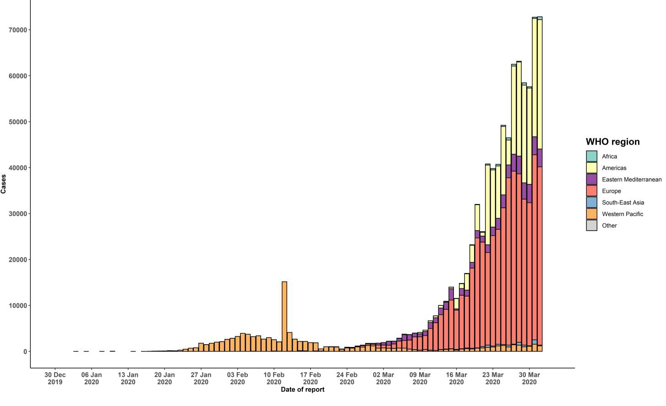

STRATEGIC OBJECTIVES

WHO’s strategic objectives for this response are to:

  - Interrupt human-to-human transmission including reducing secondary infections among close contacts and health care workers, preventing transmission amplification events, and preventing further international spread*;
  - Identify, isolate and care for patients early, including providing optimized care for infected patients;
  - Identify and reduce transmission from the animal source;
  - Address crucial unknowns regarding clinical severity, extent of transmission and infection, treatment options, and accelerate the development of diagnostics, therapeutics and vaccines;
  - Communicate critical risk and event information to all communities and counter misinformation;
  - Minimize social and economic impact through multisectoral partnerships.

*This can be achieved through a combination of public health measures, such as rapid identification, diagnosis and management of the cases, identification and follow up of the contacts, infection prevention and control in health care settings, implementation of health measures for travelers, awareness-raising in the population and risk communication.
PREPAREDNESS AND RESPONSE
- To view all technical guidance documents regarding COVID-19, please go to this webpage.
- WHO has developed interim guidance for laboratory diagnosis, advice on the use of masks during home care and in health care settings in the context of the novel coronavirus (2019-nCoV) outbreak, clinical management, infection prevention and control in health care settings, home care for patients with suspected novel coronavirus, risk communication and community engagement and Global Surveillance for human infection with novel coronavirus (2019-nCoV).
- WHO is working closely with International Air Transport Association (IATA) and have jointly developed a guidance document to provide advice to cabin crew and airport workers, based on country queries. The guidance can be found on the IATA webpage.
- WHO has been in regular and direct contact with Member States where cases have been reported. WHO is also informing other countries about the situation and providing support as requested.
- WHO is working with its networks of researchers and other experts to coordinate global work on surveillance, epidemiology, mathematical modelling, diagnostics and virology, clinical care and treatment, infection prevention and control, and risk communication. WHO has issued interim guidance for countries, which are updated regularly.
- WHO has prepared a disease commodity package that includes an essential list of biomedical equipment, medicines and supplies necessary to care for patients with 2019-nCoV.
- WHO has provided recommendations to reduce risk of transmission from animals to humans.
- WHO has published an updated advice for international traffic in relation to the outbreak of the novel coronavirus 2019-nCoV.
- WHO has activated the R&D blueprint to accelerate diagnostics, vaccines, and therapeutics.
- OpenWHO is an interactive, web-based, knowledge-transfer platform offering online courses to improve the response to health emergencies. COVID-19 courses can be found here and courses in additional national languages here. Specifically, WHO has developed online courses on the following topics:
  - A general introduction to emerging respiratory viruses, including novel coronaviruses (available in Arabic, Chinese, English, French, Russian, Spanish, Hindi, Indian Sign Language, Persian, Portuguese, Serbian and Turkish);
  - Clinical care for Severe Acute Respiratory Infections (available in English, French, Russian, Indonesian and Vietnamese);
  - Health and safety briefing for respiratory diseases - ePROTECT (available in Chinese, English, French, Russian, Spanish, Indonesian and Portuguese);
  - Infection Prevention and Control for Novel Coronavirus (COVID-19) (available in Chinese, English, French,
Russian, Spanish, Indonesian, Italian, Japanese, Portuguese and Serbian); and
  - COVID-19 Operational Planning Guidelines and COVID-19 Partners Platform to support country preparedness and response (available in English and coming soon in additional languages).
- WHO is providing guidance on early investigations, which are critical in an outbreak of a new virus. The data collected from the protocols can be used to refine recommendations for surveillance and case definitions, to characterize the key epidemiological transmission features of COVID-19, help understand spread, severity, spectrum of disease, impact on the community and to inform operational models for implementation of countermeasures such as case isolation, contact tracing and isolation. Several protocols are available here. One such protocol is for the investigation of early COVID-19 cases and contacts (the “First Few X (FFX) Cases and contact investigation protocol for 2019-novel coronavirus (2019-nCoV) infection”). The protocol is designed to gain an early understanding of the key clinical, epidemiological and virological characteristics of the first cases of COVID-19 infection detected in any individual country, to inform the development and updating of public health guidance to manage cases and reduce the potential spread and impact of infection.
RECOMMENDATIONS AND ADVICE FOR THE PUBLIC

If you are not in an area where COVID-19 is spreading or have not travelled from an area where COVID-19 is spreading or have not been in contact with an infected patient, your risk of infection is low. It is understandable that you may feel anxious about the outbreak. Get the facts from reliable sources to help you accurately determine your risks so that you can take reasonable precautions (see Frequently Asked Questions). Seek guidance from WHO, your healthcare provider, your national public health authority or your employer for accurate information on COVID-19 and whether COVID-19 is circulating where you live. It is important to be informed of the situation and take appropriate measures to protect yourself and your family (see Protection measures for everyone).

If you are in an area where there are cases of COVID-19 you need to take the risk of infection seriously. Follow the advice of WHO and guidance issued by national and local health authorities. For most people, COVID-19 infection will cause mild illness however, it can make some people very ill and, in some people, it can be fatal. Older people, and those with pre-existing medical conditions (such as cardiovascular disease, chronic respiratory disease or diabetes) are at risk for severe disease (See Protection measures for persons who are in or have recently visited (past 14 days) areas where COVID-19 is spreading).

CASE DEFINITIONS

WHO periodically updates the Global Surveillance for human infection with coronavirus disease (COVID-19) document which includes case definitions.

For easy reference, case definitions are included below.

Suspect case
  - A patient with acute respiratory illness (fever and at least one sign/symptom of respiratory disease, e.g., cough, shortness of breath), AND a history of travel to or residence in a location reporting community transmission of COVID-19 disease during the 14 days prior to symptom onset.
OR
  - A patient with any acute respiratory illness AND having been in contact with a confirmed or probable COVID-19 case (see definition of contact) in the last 14 days prior to symptom onset;
OR
  - A patient with severe acute respiratory illness (fever and at least one sign/symptom of respiratory disease, e.g., cough, shortness of breath; AND requiring hospitalization) AND in the absence of an alternative diagnosis that fully explains the clinical presentation.

Probable case
- A suspect case for whom testing for the COVID-19 virus is inconclusive.
  - Inconclusive being the result of the test reported by the laboratory.
OR
- A suspect case for whom testing could not be performed for any reason.

Confirmed case
A person with laboratory confirmation of COVID-19 infection, irrespective of clinical signs and symptoms.
- Technical guidance for laboratory testing can be found here.

Definition of contact
A contact is a person who experienced any one of the following exposures during the 2 days before and the 14 days
after the onset of symptoms of a probable or confirmed case:
- Face-to-face contact with a probable or confirmed case within 1 meter and for more than 15 minutes;
- Direct physical contact with a probable or confirmed case;
- Direct care for a patient with probable or confirmed COVID-19 disease without using proper personal protective equipment1; OR
- Other situations as indicated by local risk assessments.

Note: for confirmed asymptomatic cases, the period of contact is measured as the 2 days before through the 14 days
after the date on which the sample was taken which led to confirmation.

1 World Health Organization. Infection prevention and control during health care when COVID-19 is suspected https://www.who.int/publications-detail/infection-prevention-and-control-during-health-care-when-novel-coronavirus-(ncov)- infection-is-suspected-20200125

